Year 8 Science

The Human Digestive System.

Use your textbook and your laptop to label the following diagram, colour it in and fill in the table below.
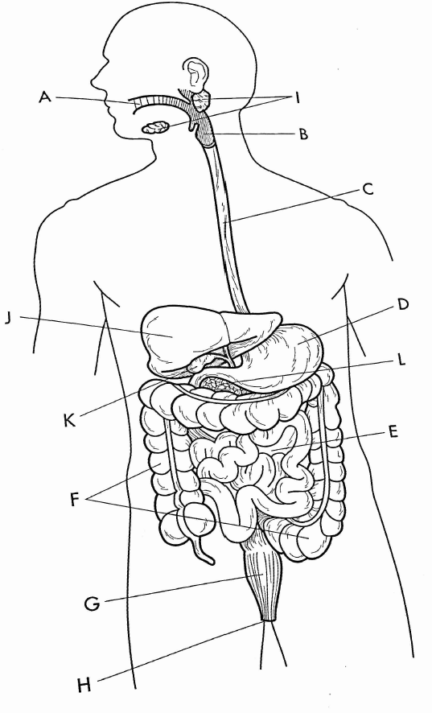
Letter | Colour | Organ’s name | What does it look like? (structure) | What does it do? (function) | What type of digestion (if any) is it involved with?
A |  | Mouth | Teeth and tongue.  Cavity in which food is chewed | Mixes food and saliva. Breaks food down into smaller pieces | Chemical: enzyme in saliva breaks chemical bonds  Mechanical: Teeth breaks food into smaller pieces
B |  | Epiglottis | Flap that separates oesophagus and trachea | Closes off your trachea so that food doesn’t go down to your lungs | None
C |  | Oesophagus | Hollow tube lined with mucous and cartilage rings | Transports food to the stomach using involuntary muscular contractions | None
D |  | Stomach | J-shaped organ. Muscular walls.  Contains hydrochloric acid | Muscles mix food with gastric juice and breaks down proteins. | Mechanical: Muscle movements separate food  Chemical: gastric juice breaks proteins into smaller molecules
E |  | Small Intestine | 6m long tube.  Contains enzymes | Digests most food | Chemical: Enzymes break down molecules into smaller ones.  Mechanical: Separates food by peristalsis
F |  | Large intestine | 1.5 m long tube. Wider than the sml int. | Absorb water, salts and vitamins | None
G |  | Rectum | Final part of the large intestine | Stores faeces before removal | None
H |  | Anus | Ring of muscle | Controls removal of faeces | None
I |  | Salivary glands |  | Release saliva into the mouth | Chemical: releases enzymes that break down starch
J |  | Liver | Largest organ | Makes bile, which breaks down fats. | None
K |  | Gall Bladder | Hollow organ | Stores bile | Mechanical: bile separates fats.
L |  | Pancreas | Looks like a sponge | Release pancreatic juice, containing enzymes that break down proteins, fats and carbohydrates. | Chemical: secretes enzymes which chemically break down substances

